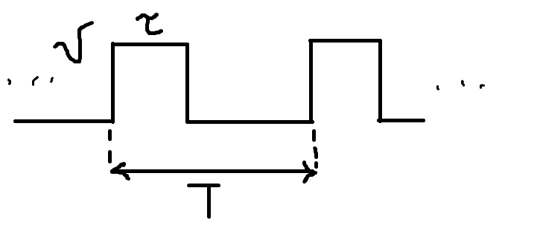
$$Q=\frac{T}{τ}⇒скважность \\ 1) x\left(t\right)=\sum_{n=1}^{∞}{C_{n}ϕ_{n}\left(t\right)} \left\{ϕ_{n}\right\}⇒СБФ \\ 2) C_{n}=\frac{1}{{\left\|ϕ_{n}\right\|}^{2}}\int{x\left(t\right)ϕ_{n}\left(t\right) dt}$$
$$x\left(t\right)=\frac{a_{0}}{2}+\sum_{n=1}^{∞}{\left(a_{n}\cos{nω_{1}t}+b_{n}\sin{nω_{1}t}\right)}=\frac{a_{0}}{2}+\sum{A_{n}}\cos\left(nω_{1}t+θ_{n}\right) \\ A_{n}=\sqrt{a_{n}^{2}+b_{n}^{2}} \\ θ_{n}=-\operatorname{atan}{\frac{b_{n}}{a_{n}}}$$
$$S_{1}=\int_{0}^{T}{x\left(t\right) dt} \\ S_{2}=A_{0}T \\ S_{1}=S_{2}$$
$$A_{0}=\frac{1}{T}\int_{0}^{T}{x\left(t\right) dt} \\ a_{n}=\frac{2}{T}\int{x\left(t\right)\cos{nω_{1}t} dt}=\frac{2}{T}\int_{-\frac{τ}{2}}^{\frac{τ}{2}}{U\cos{nω_{1}t} dt}=\frac{2U}{Tnω_{1}}\int_{-\frac{τ}{2}}^{\frac{τ}{2}}{\cos{nω_{1}t} d\left(nω_{1}t\right)}= \\ =\frac{2U}{Tnω_{1}}\sin{nω_{1}t}{\left.​\right|}_{-\frac{τ}{2}}^{\frac{τ}{2}}=\frac{2U}{Tnω_{1}}\left(\sin{\frac{nω_{1}τ}{2}}-\sin\left(-\frac{nω_{1}τ}{2}\right)\right)=…=\frac{2U}{πn}\sin{\frac{πnτ}{T}}=\frac{2U}{πn} \sin{\frac{πn}{2}}$$
Коэффициент $a_{n}$ можно представить и в таком виде:
$$a_{n}=2U⋅\frac{τ}{T}⋅\frac{\sin{πn⋅\frac{τ}{T}}}{πn\frac{τ}{T}}$$
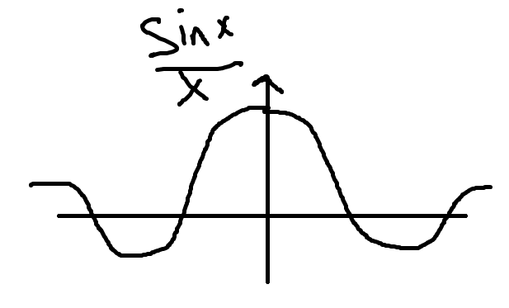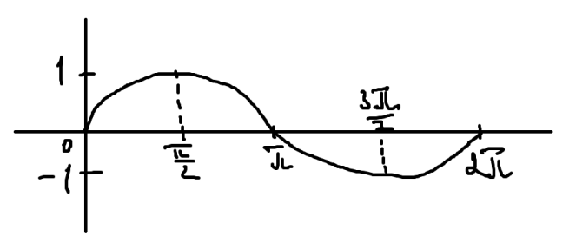
$$a_{n}=\left\{\begin{aligned}0, при n=0, 2, 4,… \\ \frac{2U}{πn}, при n=1, 5, 9,… \\ -\frac{2U}{πn}, при n=3, 7, 11, …\end{aligned}\right.$$
$$S=Uτ=A_{0}T⇒A_{0}=\frac{Uτ}{T}$$
$$x\left(t\right)=\frac{a_{0}}{2}+\sum_{n=1}^{∞}{a_{n}\cos{nω_{1}t}}=U\left(\frac{τ}{T}+\frac{2}{π}\sum_{n=1}^{∞}{\sin{\frac{πnτ}{T}}\cos{nω_{0}t}}\right)$$
Построим спектральную диаграмму для скважности = 2, с учётом того, что $\left|a_{n}\right|=\frac{2U}{πn}\sin{\frac{πn}{2}}$:
$$\left|a_{1}\right|=0,63 U \\ \left|a_{3}\right|=0,21 U \\ \left|a_{5}\right|=0,12 U \\ \left|a_{7}\right|=0,09 U \\ \left|a_{9}\right|=0,07 U \\ A_{0}=0,5 U$$
